EXPT NO: 5 | IMPLEMENTATION OF A RECURRENT NEURAL NETWORK (RNN) FOR TEXT GENERATION
DATE: 24th August,2026

PRE-LAB QUESTIONS (PROVIDE BRIEF ANSWERS TO THE FOLLOWING QUESTIONS)

1. Explain the purpose of a Recurrent Neural Network (RNN) in processing sequential data.

A Recurrent Neural Network (RNN) is designed to process sequential data by considering the order and relationship between elements. Unlike traditional neural networks, an RNN maintains a hidden state that carries information from previous time steps. This enables it to understand patterns and dependencies in sequences such as text, speech, time-series data, and sensor readings. Thus, RNNs are useful for tasks where past information influences the current output.

2. Why is an RNN considered an appropriate model for text generation tasks?

RNNs are appropriate for text generation because text is inherently sequential, where the meaning of a word often depends on previously occurring words. An RNN processes words one by one while maintaining information about earlier words through its hidden state. It can therefore learn language patterns, grammar, and word relationships. After training, the RNN can predict the next word based on the preceding sequence and generate meaningful text.

3. Describe the concept of sequence modeling in natural language processing.

Sequence modeling in Natural Language Processing (NLP) refers to analyzing and understanding data where the order of elements is important. In language, words appear in a specific sequence, and changing their order can change the meaning of a sentence. Sequence models learn relationships and dependencies between words or tokens. They are used for applications such as text generation, machine translation, sentiment analysis, speech recognition, and language prediction.

4. Explain the importance of tokenization during text preprocessing for RNN-based text
generation.

Tokenization is an important preprocessing step that divides text into smaller units called tokens, such as words, subwords, or characters. RNNs cannot directly process raw text, so tokenization converts sentences into manageable sequences. Each token can then be assigned a numerical index for model processing. Proper tokenization helps the RNN identify meaningful patterns and relationships between words, improving its ability to learn language structure and generate text.

5. Explain the significance of converting text into numerical representations before training an RNN.

Converting text into numerical representations is essential because neural networks, including RNNs, operate on numerical data rather than raw characters or words. After tokenization, each token is mapped to a numerical value or vector representation. These numerical inputs allow the RNN to perform mathematical operations and learn patterns from the training data. Techniques such as word embeddings can also capture semantic relationships between words, improving text-generation performance.

AIM
To implement a Recurrent Neural Network (RNN) for text generation and evaluate its ability to generate meaningful text by predicting the next word in a sequence.

SOFTWARE REQUIREMENTS
- Python
- TensorFlow or keras or PyTorch
- Google Colab
- GitHub
- Numpy
- Matplotlib

OBJECTIVES
Students will be able to:
- Understand the architecture and working of Recurrent Neural Networks (RNNs).
- Perform text preprocessing techniques for sequence modeling.
- Generate input sequences suitable for training an RNN model.
- Build and train an RNN model for text generation.
- Generate text by predicting the next word in a sequence.
- Evaluate the performance of the trained RNN using generated text.
- Analyze the effectiveness of RNNs in learning sequential patterns from textual data.

PROCEDURE
PART A: DATASET PREPARATION
Perform the following tasks:
- Load the Tiny Shakespeare dataset from Hugging Face.
- Explore the dataset and examine the text samples.
- Convert the text into lowercase (if required).
- Tokenize the text into individual words.
- Build a vocabulary and assign a unique integer index to each word.
- Generate input sequences for next-word prediction.
- Apply sequence padding to obtain inputs of equal length.
- Split the prepared sequences into training and validation datasets.

PART B: IMPLEMENTING THE RNN MODEL
Perform the following tasks:
- Create an Embedding layer to convert words into dense vector representations.
- Add a Simple RNN layer to learn sequential dependencies in the text.
- Add a Dense output layer with Softmax activation for next-word prediction.
- Compile the model using an appropriate optimizer and loss function.
- Display the model architecture and summary.

PART C: COMPARISON OF OPTIMIZATION ALGORITHMS
Perform the following tasks:
- Train the RNN model using the prepared training dataset.
- Validate the model using the validation dataset.
- Record:
  - Training accuracy
  - Validation accuracy
  - Training loss
  - Validation loss
- Visualize:
  - Accuracy vs. Epoch
  - Loss vs. Epoch

PART D: DEEP LEARNING EXPERIMENT MANAGEMENT
Perform the following tasks:
- Provide a seed word or sentence as input to the trained model.
- Generate text by repeatedly predicting the next word in the sequence.
- Produce multiple text samples using different seed inputs.
- Compare the generated text for coherence and contextual relevance.
- Document the observations and upload the notebook to GitHub.

EXPECTED OUTCOME
Students will understand how an RNN learns sequential information and generates meaningful text based on previously learned patterns. Students will learn to preprocess textual data and train a Recurrent Neural Network (RNN) for text generation. They will evaluate the model's performance using training metrics and generate text through next-word prediction.

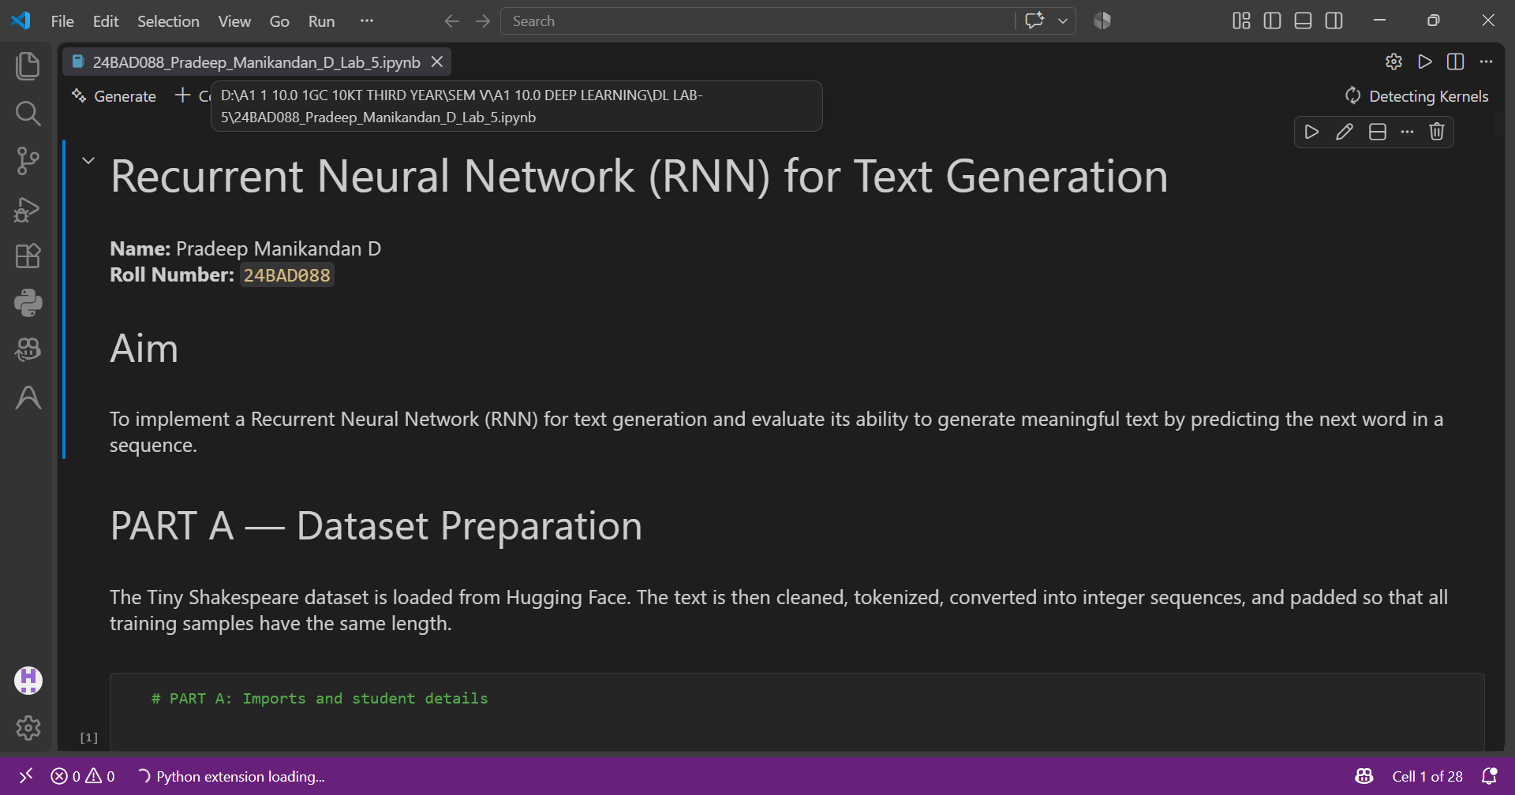

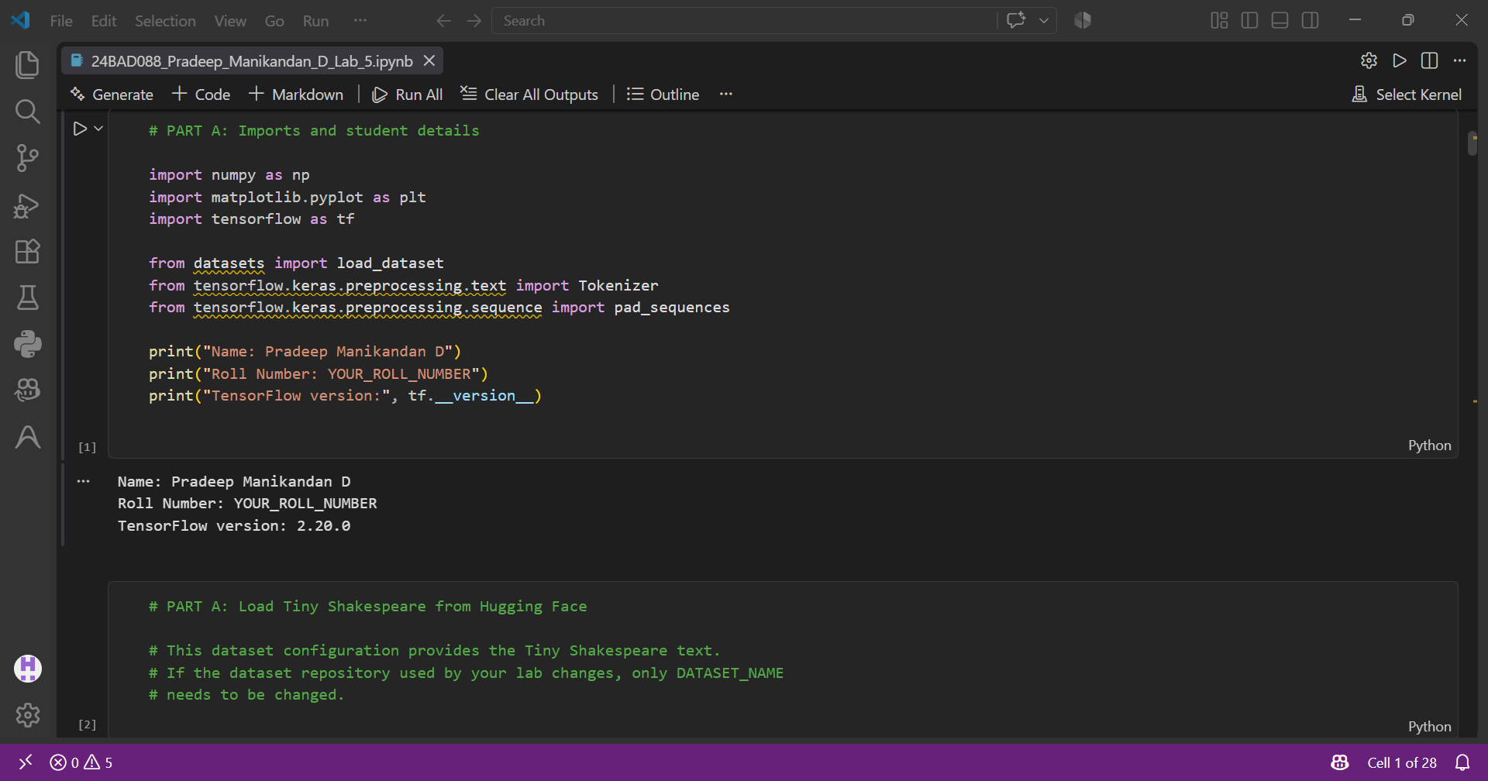

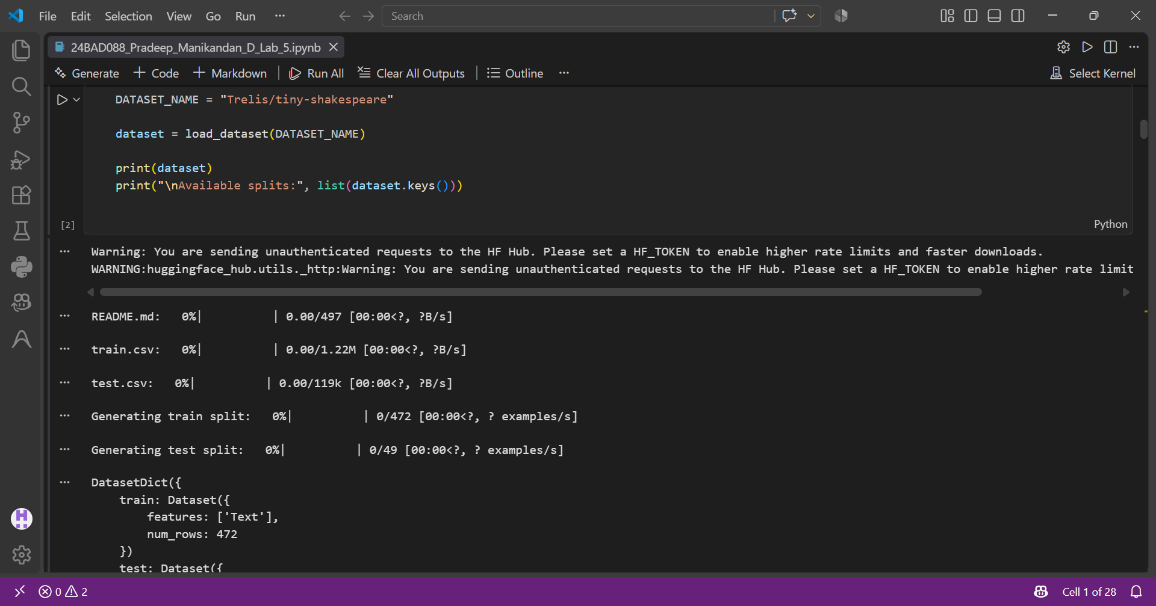

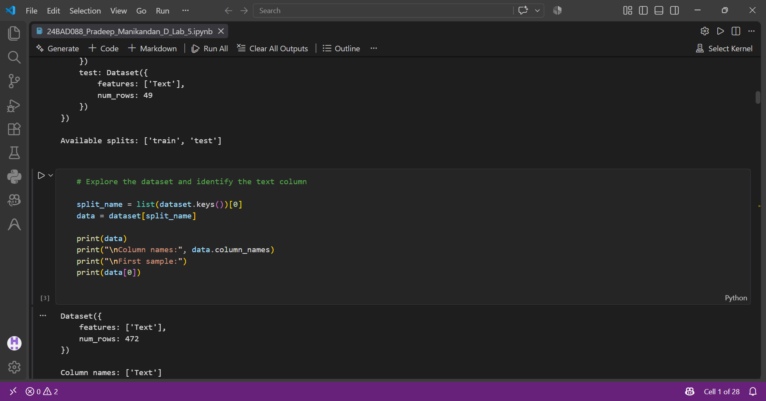

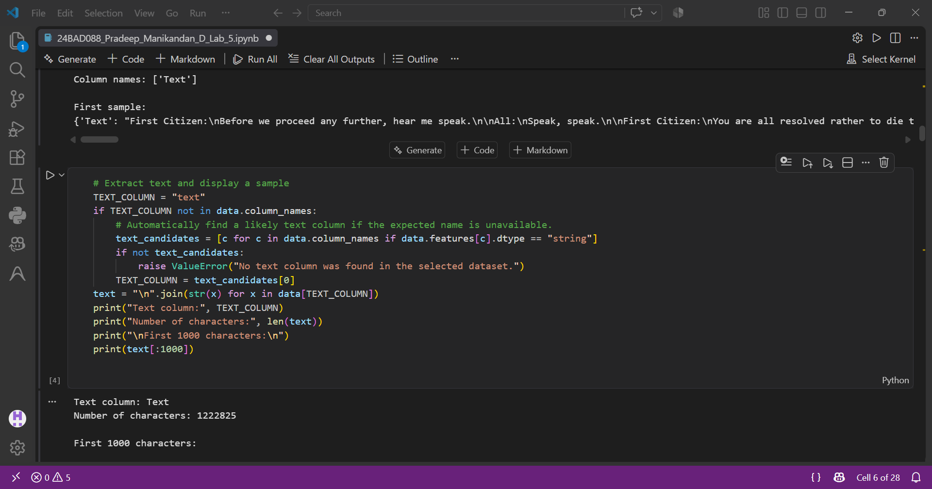
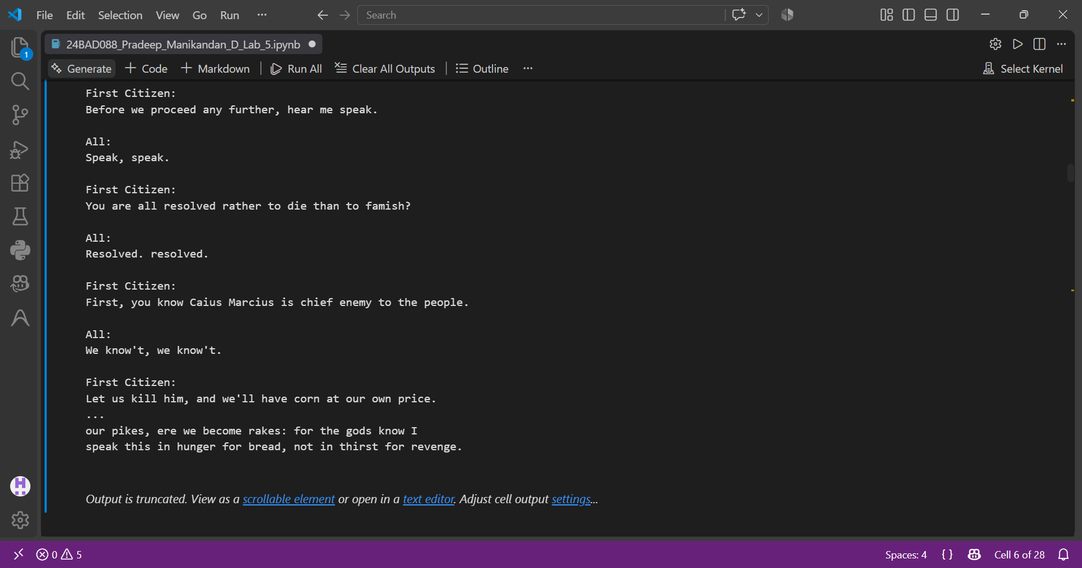
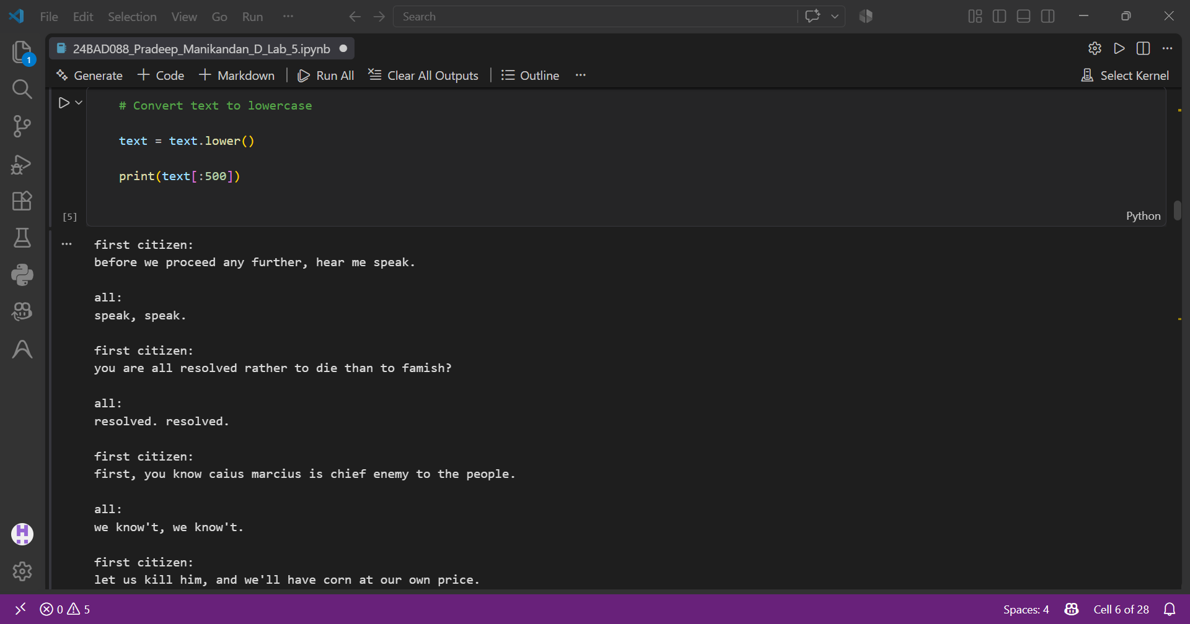
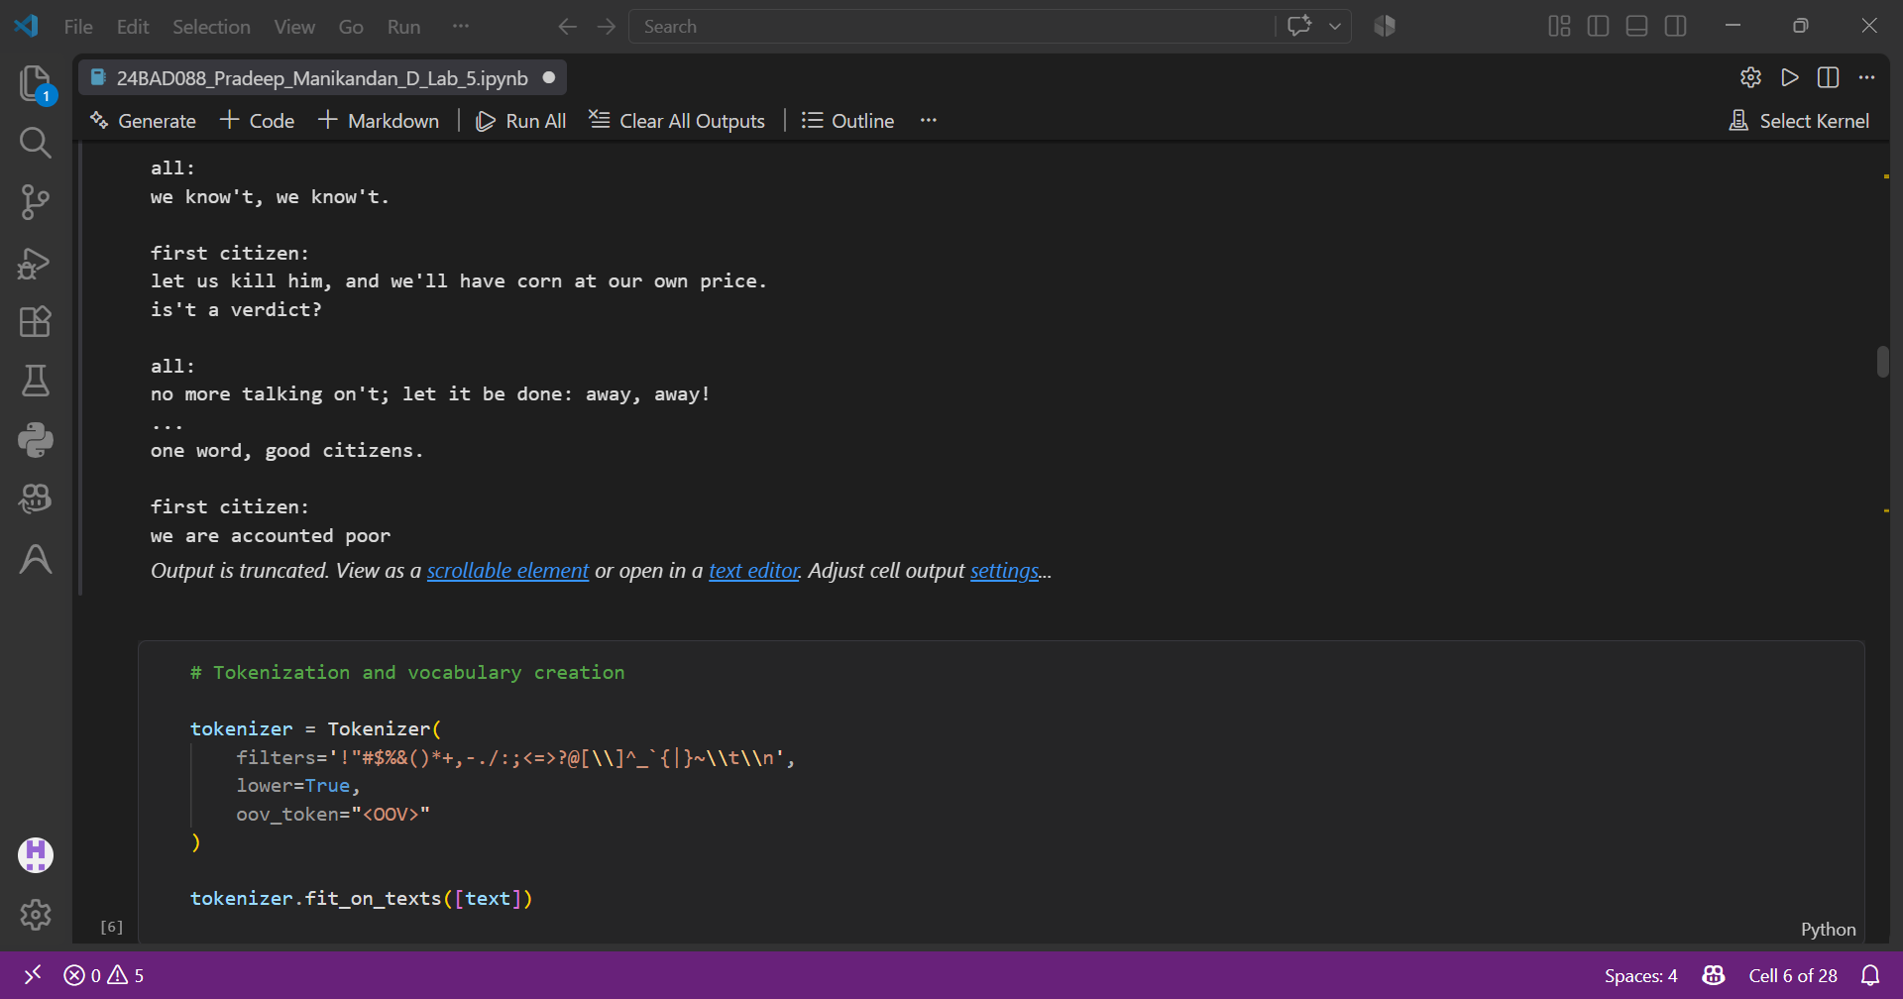

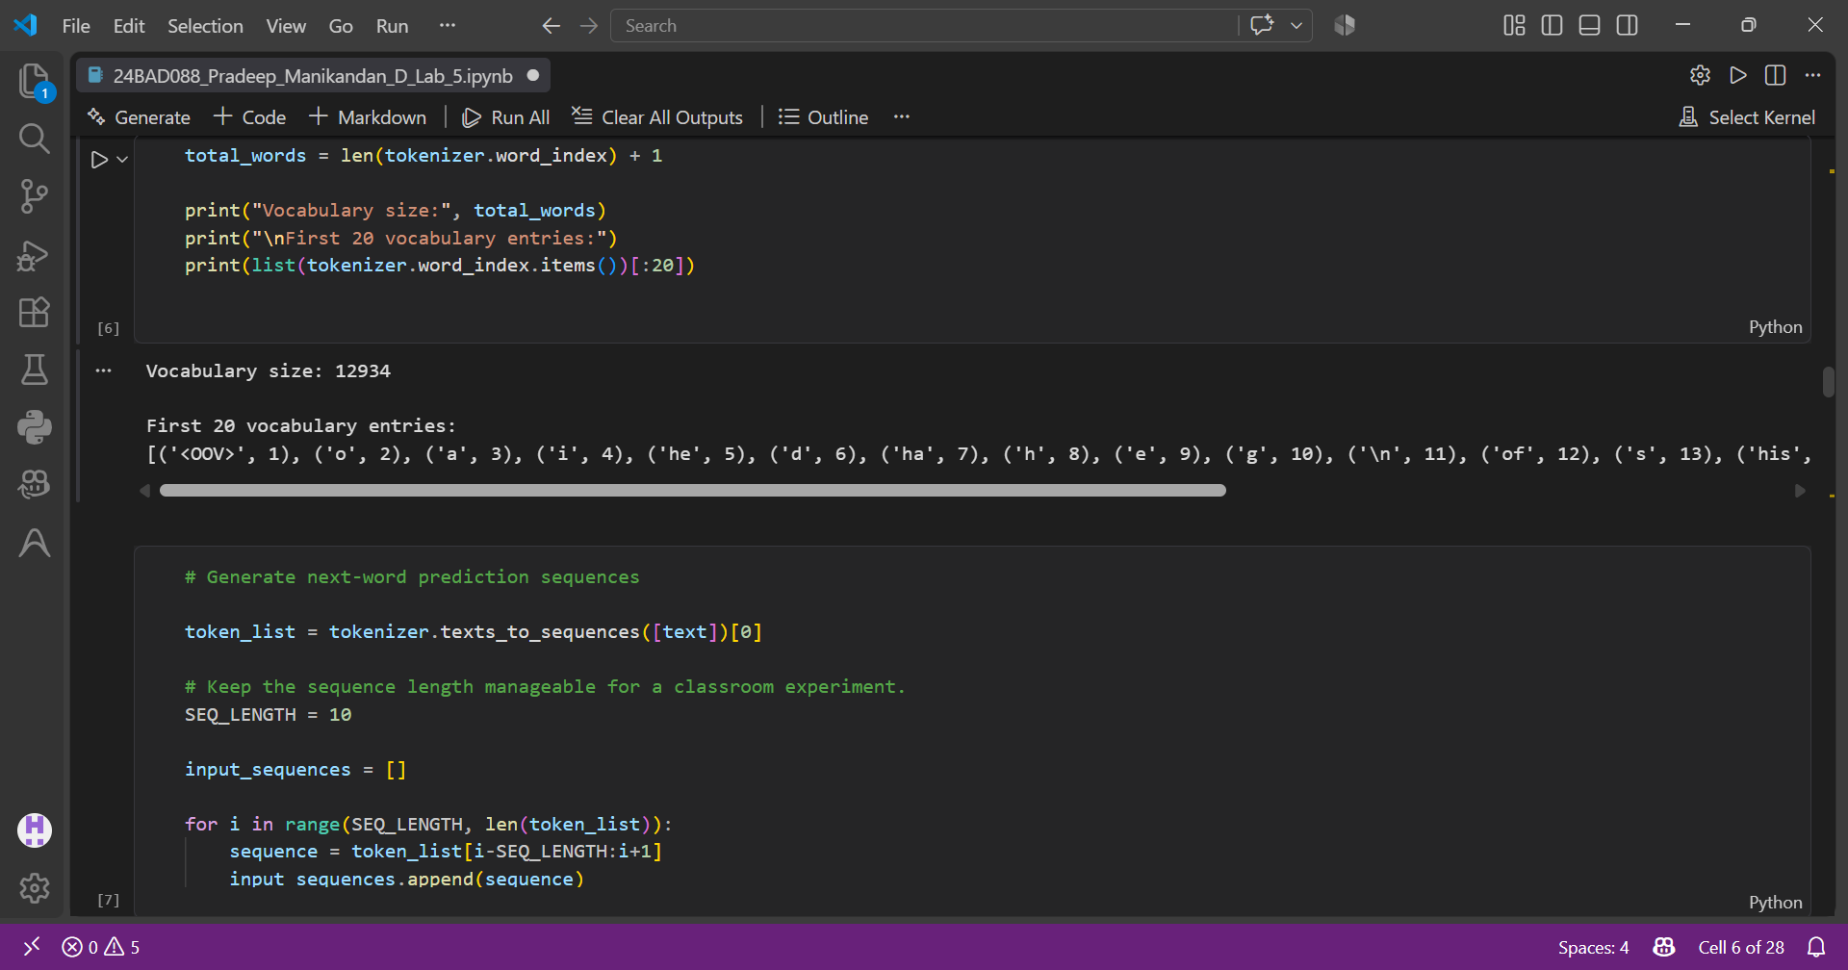
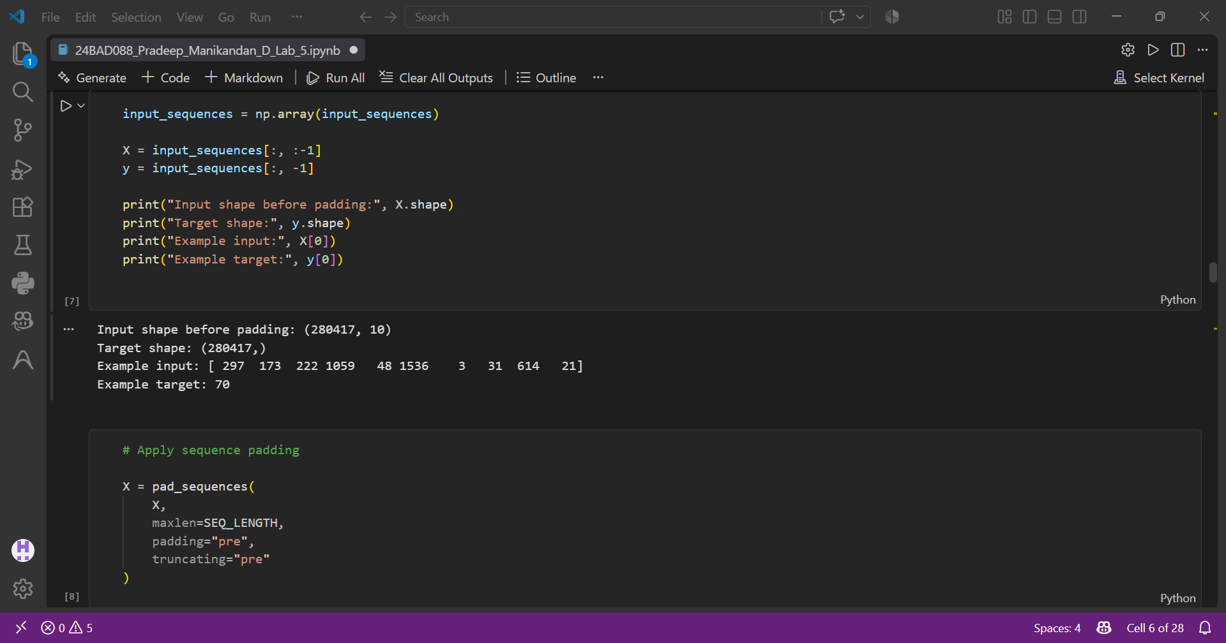
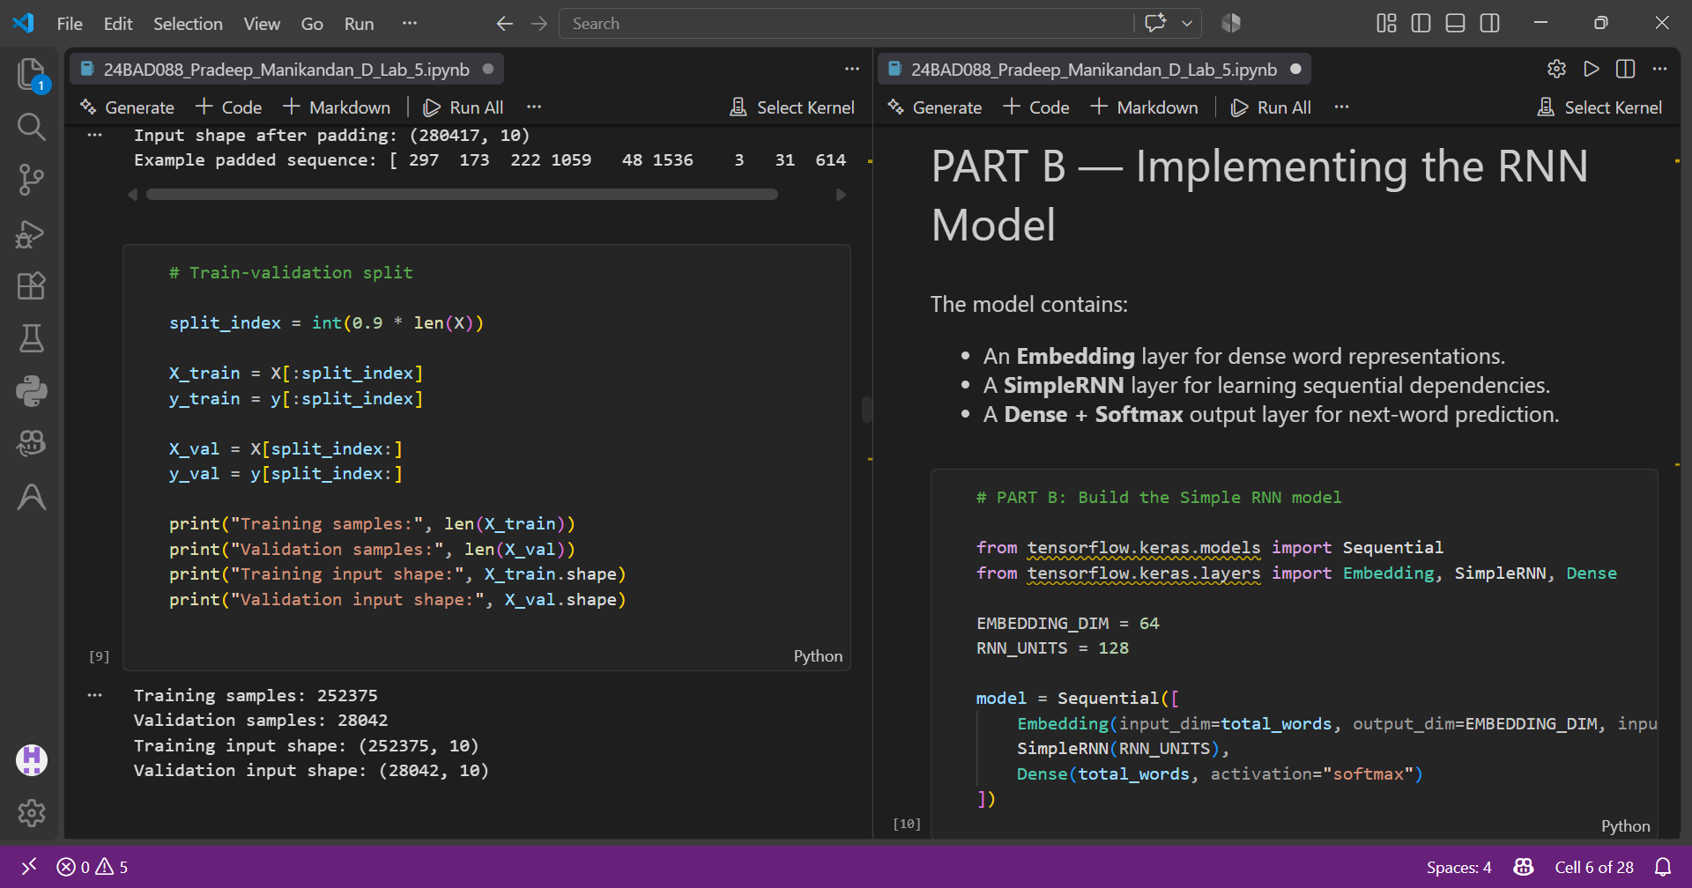
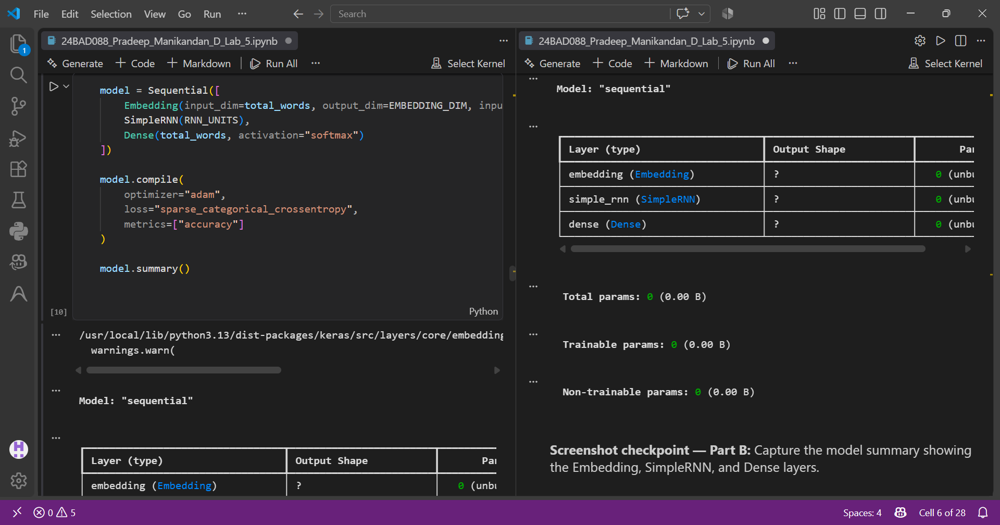
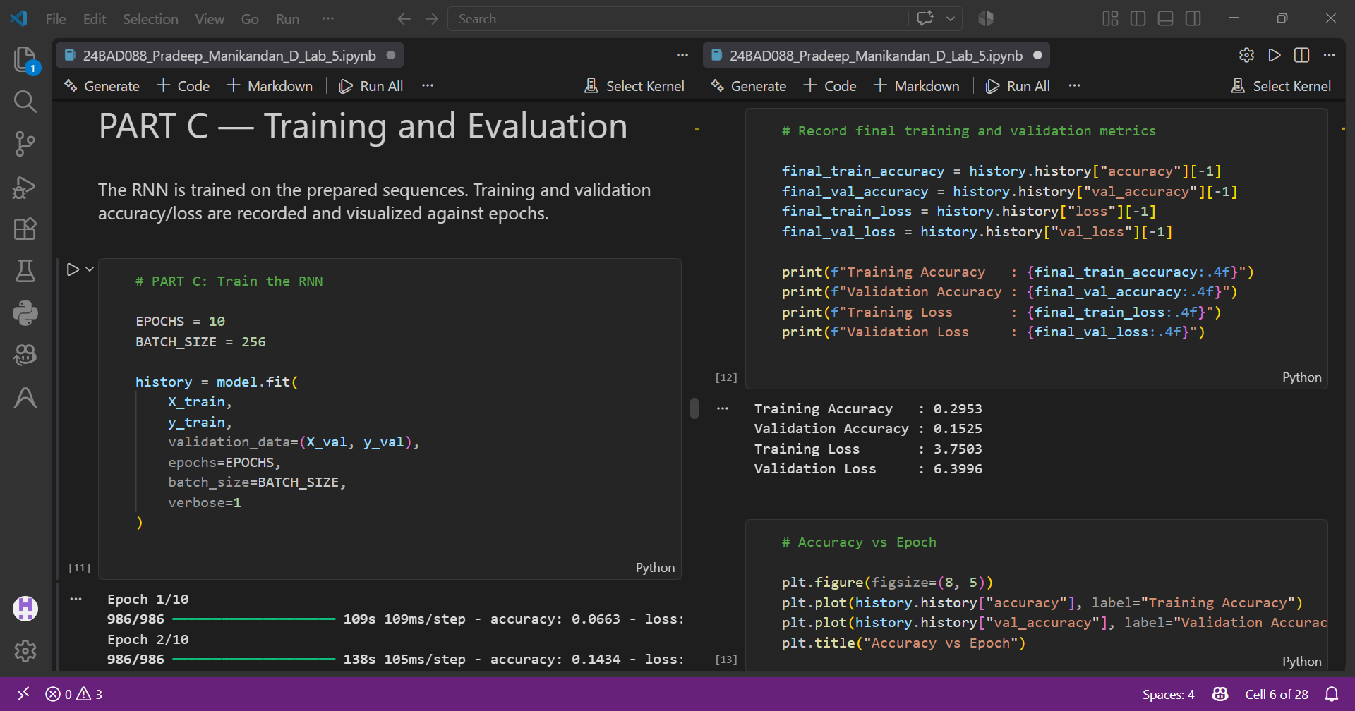
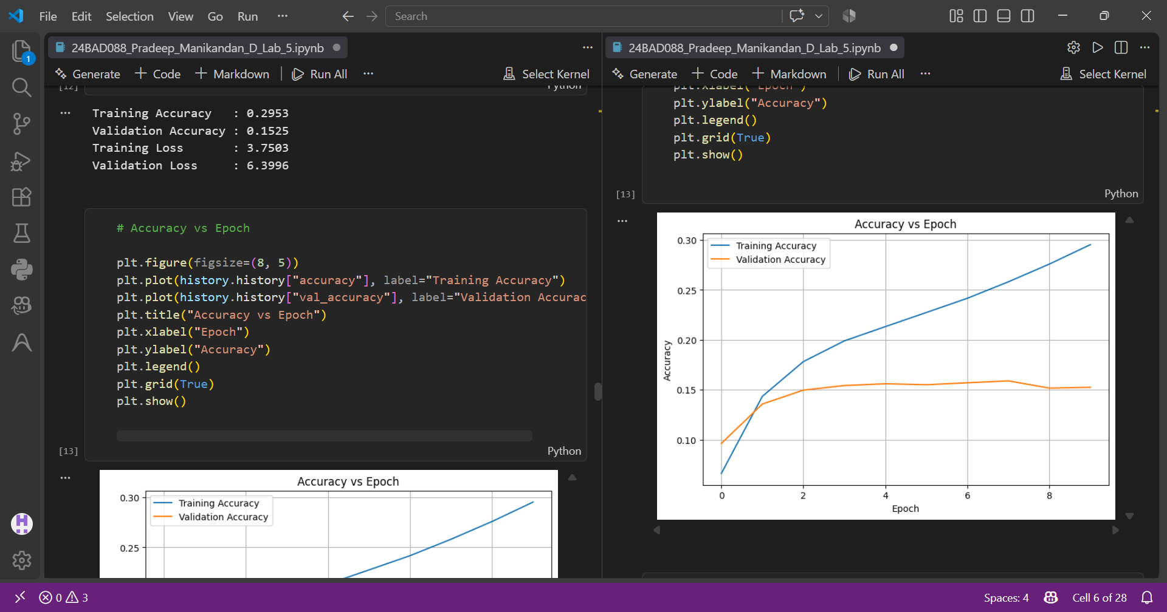
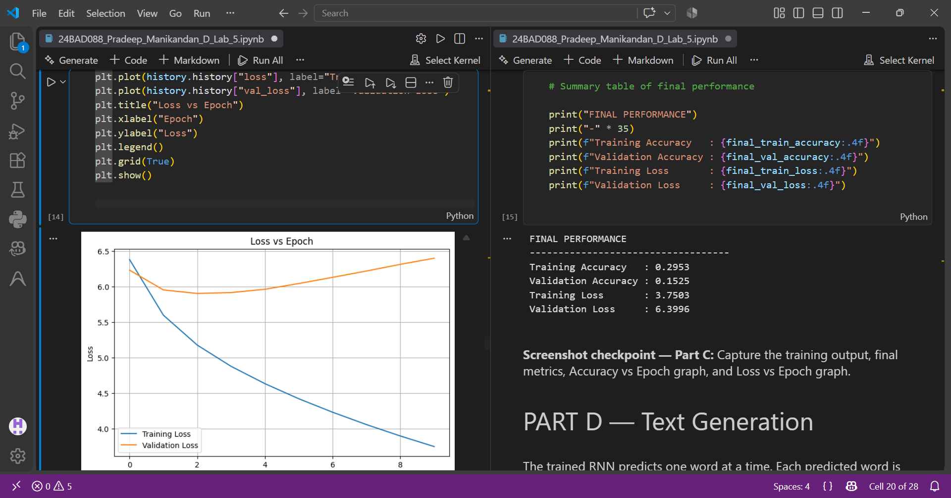
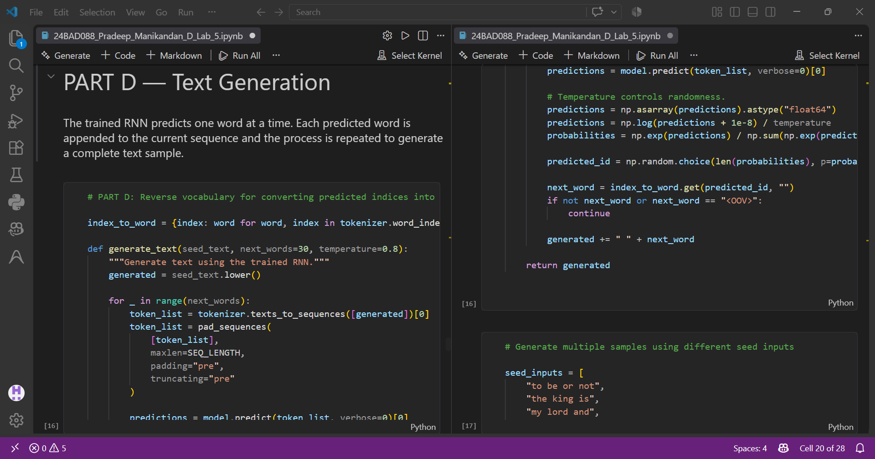
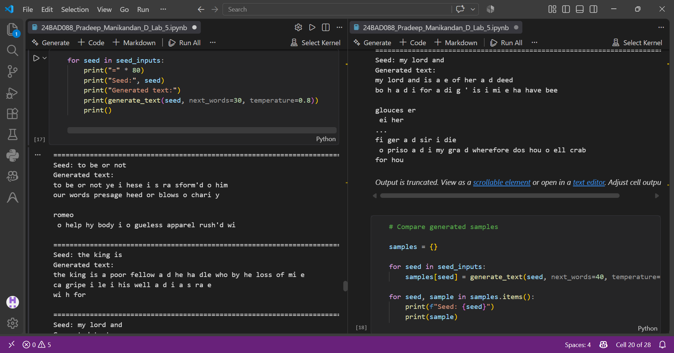
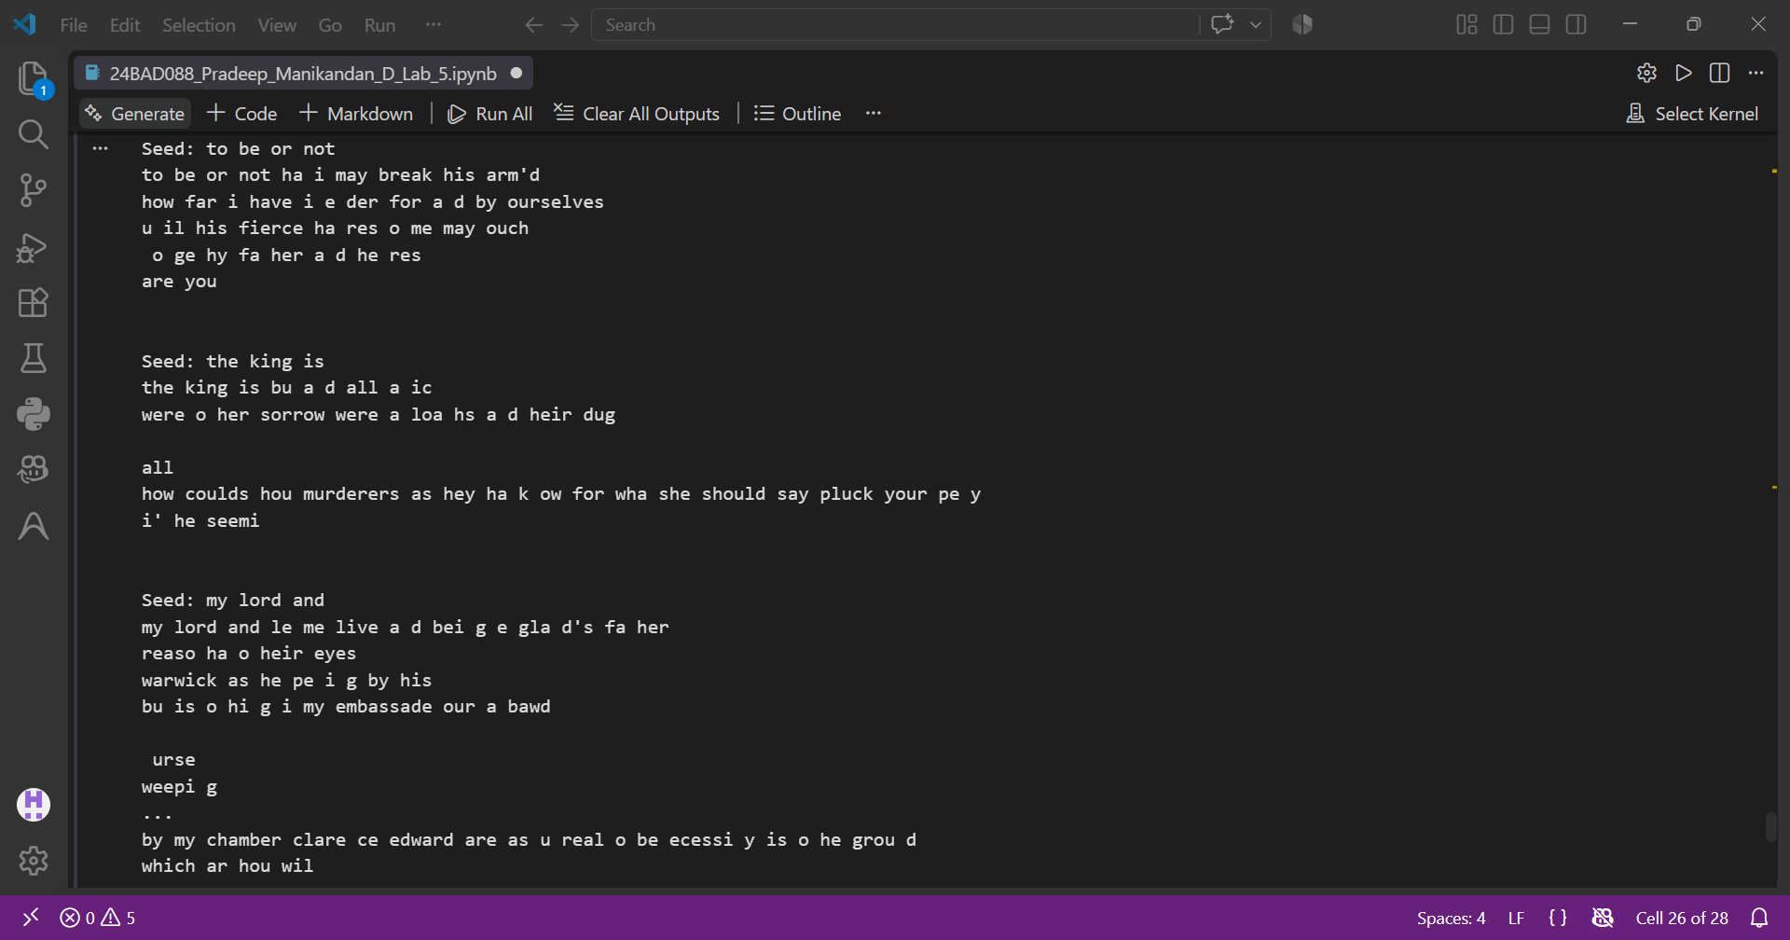

https://github.com/Pradeep-Manikandan-1-D/24BAD088_DEEP_LEARNING_LAB/upload/main

POST-LAB QUESTIONS (PROVIDE BRIEF ANSWERS TO THE FOLLOWING QUESTIONS)

1. Describe the role of the hidden state in an RNN during sequence processing.

The hidden state in an RNN acts as the model’s memory during sequence processing. It stores information from previous time steps and passes relevant information to the next step. At each time step, the hidden state is updated using the current input and the previous hidden state. This allows the RNN to learn relationships and dependencies between elements in a sequence, making it useful for processing text and other sequential data.

2. Discuss the effect of training an RNN model for an insufficient number of epochs.

Training an RNN for an insufficient number of epochs can result in underfitting. The model may not receive enough training iterations to learn important patterns, relationships, and dependencies present in the data. Consequently, it may produce poor predictions and generate repetitive or meaningless text. The training and validation accuracy may remain low, while the loss remains relatively high. Increasing the number of epochs appropriately can help the model learn more effectively.

3. Explain the purpose of padding when preparing text sequences for RNN training.

Padding is used to make text sequences equal in length before providing them to an RNN. Since sentences or sequences can contain different numbers of tokens, padding adds special values, usually zeros, to shorter sequences. This creates a uniform input shape that can be processed efficiently in batches. Padding ensures that all sequences have the same length while allowing the model to distinguish actual text tokens from added padding values.

4. Discuss one limitation of a Simple RNN when processing long text sequences.

One major limitation of a Simple RNN is its difficulty in learning long-term dependencies. When processing long sequences, information from earlier time steps can gradually become weaker as it passes through many recurrent operations. This problem, known as the vanishing gradient problem, makes it difficult for the model to remember important information from the beginning of a long text. Therefore, Simple RNNs often perform better on shorter sequences.

5. Discuss the effect of sequence length on the performance of the text generation model.

Sequence length determines how much previous text the RNN considers when predicting the next token. A short sequence may not provide enough context, resulting in less meaningful or grammatically incorrect generated text. A longer sequence provides more context and can improve predictions, but it also increases computational requirements and may make training more difficult. Therefore, an appropriate sequence length must balance contextual information, computational efficiency, and model performance.

ASSESSMENT
Description | Max Marks | Marks Awarded
Pre Lab Exercise | 5
In Lab Exercise | 10
Post Lab Exercise | 5
Viva | 10
Total | 30
Faculty Signature

